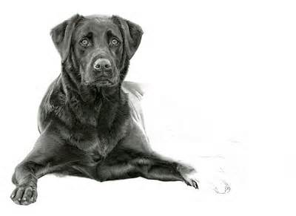
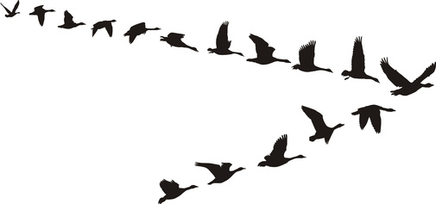
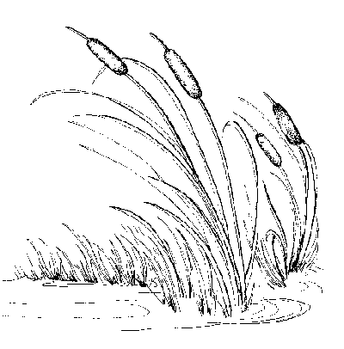
Muck Madness Retrievers
Retrievers, from the Sofa to the Swamp!!
www.muckmadnessretrievers.com

HIP Guarantee
With pre-screening and OFA certification every possible precaution has been taken to assure your pup’s hips are good. However, with past historical breeding practices it will take years and generations of screening to eradicate the potential of this issue. Both parents’ hips through x-rays are rated good or better by the Orthopedic Foundation for Animals (OFA).
Your puppy’s hips are guaranteed to be OFA fair or better until 30 months of age. Due to bone and hip development, testing and certification can’t take place until your pup is 2 years of age. The 30 month guarantee gives you 6 months to complete the x-rays and obtain clearance.
Should you pup be found to have poor or worse (dysplastic) the owner must provide proof of rejection (original OFA finding letter) as well as x-rays for review. In this event we will provide a full refund and if the owner desires take the dog back.
If the dog has been bred prior to the test or sustained a major injury (broken bones; this guarantee if void.

Note of caution; please use a veterinarian clinic that has experience in OFA certification. Proper hip manipulation and positioning the dog under an anesthetic is critical. Many false readings are due to inexperience Veterinarians and improper hip positioning.
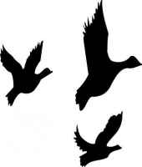
Mark & Helen Berger
8622 Weaver RD, Chittenango NY 13037
315-727-3820

